**MKT572 Group Project**

**There are several requirements for group project. Failure to meet the submission requirement will result in a deduction of 10 points from your grade.**

1. **In your cover page, list the full name of all group members, course number and section number.**
2. **Each group can only send one combined file.**
3. **All data files are already uploaded under doc sharing.**
4. **Only word file is accepted. Please limit your assignment length within 25 pages for the chapter 15 and chapter 16 exercises. For the case analysis, you**
5. **Please copy and paste only relevant tables and figures into your word file.**
6. **Please use this template for your group reports (except for the case analysis). Please be noted that some questions are procedures. You don’t need to provide answers. For those questions requiring your answer, I put a “Answer:” below each question. You need to provide your answers to those questions. If I provide an example in the answer, you should follow my example. For some questions, I give answers directly. If I state that the answer is already provided, you don’t need to answer those questions.**
7. **Chapter 15, EX1 requires you to use the SPSS movie data with error. This is the only exercise that needs to be done using the data with errors. All datasets are uploaded under doc sharing. Question 1 of Chapter 15 use the file titled " program file. movie. attendance. with errors. sav" . The other questions use the file "program file.movie attendance. sav".The case data set is “ case EFCU.sav”.**
8. **If your group member does not finish his/her part or don’t respond to group emails, please notify me at least one week ahead of submission. I may eliminate this person from your group and let the person do the project alone. Please be noted that it is your group’s responsibility to submit a complete project report. Your grade is only based on the final report. If a person fails to finish his/her part, your group is responsible for the completion of the report. My suggestion is that everyone should finish all parts of the project and compare your answers inside group members.**
9. **In the end of the project, there is a peer evaluation form for you to fill in. Please read the instructions carefully. I don’t allow for any type of free rider behavior in group project. If you feel your group member does not deserve the credit, just let me know. It is possible that a particular member gets zero score due to lack of contribution.**
10. **Point Distribution 120 points**

**Chapter 15 EX.1 (20 points)**

**Chapter 15 EX.2 (20 points)**

**Chapter 15 EX.3 (30 points)**

**Chapter 15 EX.4 (20 points)**

**Chapter 16 EX.3 (30 points)**

Chapter 15. P.391, SPSS Exercise 1(20 points)

**EXERCISE 1: Machine Cleaning Data**

**1. Go to the Wiley Web site at** [**www.wiley.com/college/mcdaniel**](http://www.wiley.com/college/mcdaniel) **and download the** ***Segmenting the College Student Market for Movie Attendance* database to SPSS Windows. This database will have several errors for you to correct. In the SPSS Data Editor, go to the *variable view* option and notice the computer coding for each variable.**

**2. Also from the Wiley Web site, download a copy of the *Segmenting the College Student Market for Movie Attendance* questionnaire. Notice the computer coding for each of the variables, which is the same as that in the *variable view* option on the SPSS Data Editor. This information will be important in finding errors in the database.**

**3. In the SPSS Data Editor, invoke the *analyze/descriptive statistics/frequencies* sequence to obtain frequencies for all of the variables in the database.**

**4. From the SPSS Viewer *output screen*, determine which variables have input errors. Summarize the errors using the template below as a guide.**

**Answer:**

|  |  |  |  |
| --- | --- | --- | --- |
| *Questionnaire Number* | *Variable Containing Error* | *Incorrect Value* | *Correct Value* |
| 82 | Q1 | 2 | 1 |
|  |  |  |  |
|  |  |  |  |
|  |  |  |  |
|  |  |  |  |
|  |  |  |  |
|  |  |  |  |

**Go back to the *data view* screenof the *SPSS Data Editor*:**

**5. Another possible source of errors is in question 8. Notice that in this question the sum of the answers should be 100 percent. Create a summated variable for question 8 (Q8a + Q8b + Q8c + Q8d) to check for errors invoking the *transform/compute* sequence. Now compute a frequency distribution for Q8sum. The values that are not “100" indicate an input error. (Such an error could be the result of the respondent not totaling percentages to 100, but for this machine cleaning exercise, the assumption is that it is an input error). Summarize the errors using the template above.**

**Answer:**

|  |  |  |  |
| --- | --- | --- | --- |
| *Questionnaire Number* | *Variable Containing Error* | *Incorrect Value* | *Correct Value* |
|  |  |  |  |
|  |  |  |  |

**6. Once you have completed summarizing the variables containing errors, go back to the *data view* screen of the SPSS Data Editor. Position the cursor on each of the variables containing errors. Use the *ctrl-f* function to find the questionnaire numbers where the errors occurred. At this point, you will need the corrected or the database with no errors. Your professor has access to this database with no errors. After getting the corrected database, finish filling in the table in (4) above with the correct values. Then make the changes in your database, so that you have a database with no errors. Be sure to resave your database after correcting it for errors.**

**7. After machine cleaning your data, rerun the *analyze/descriptive statistics/frequencies* sequence to obtain frequencies for your corrected database.**

**8. You will use the results of this exercise to answer the questions in Exercises 2 and 4.**

**Note: You can just use the data set without error under doc sharing to finish the rest of the projects.**

Chapter 15 SPSS Exercise 2(20 points)

**EXERCISE 2: Analysis of Data with Frequency Distributions**

**Note: Use Percent (with missing value counting). Do not use valid percent (missing values are not counted).**

**1. What percentage of all respondents attended at least *1* movie in the past year?**

**Answer:** 450/500 = 0.90

The answer is 90%

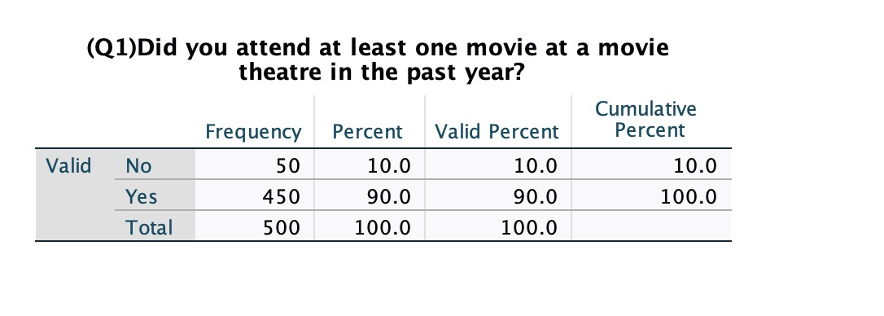

**2. What percentage of all respondents *never buy food items* at a movie?**

**Answer:** 131/500 = 0.262

= 26.2%

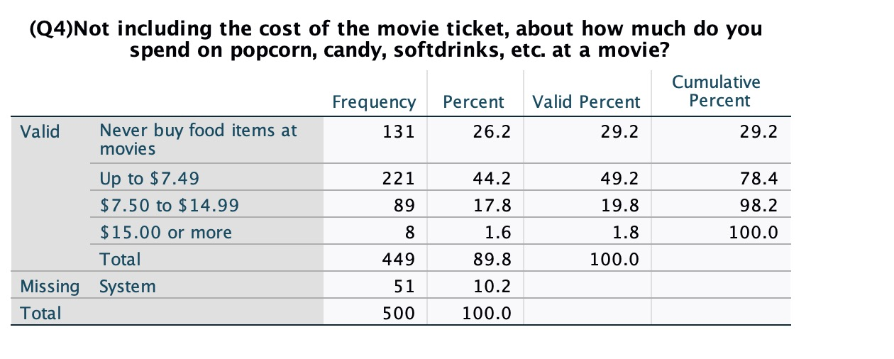

**3. Produce a table indicating the percentage of all respondents that consider each of the movie theater items in question 5 of the questionnaire *very important*. List the top 5 movie items in descending order (start with the movie items that have the highest percentage of the *very important* responses).**

**Answer:**

|  |  |  |
| --- | --- | --- |
| *Most Important Movie Theater Selection Factors* | | |
| *Rank* | *Selection Factor* | *Percentage favoring* |
| 1 | Comfortable Chairs (Q5d) | 63.00% |
| 2 | Clean Restrooms (Q5i) | 58.20% |
| 3 | Quality of Sound System Q5g) | 57.60% |
| 4 | Size of Screens (Q5f) | 50.20% |
| 5 | Auditorium Type Seating (Q5e) | 46.60% |
| 6 | Plentiful restrooms (Q5c) | 30.20% |
| 7 | Number of Screens Available (Q5h) | 19.4% |
| 8 | Soft Drinks and Food (Q5b) | 10.8% |
| 9 | Video Arcade at the movie Theatre(Q5a) | 1.20% |

**4. What percentage of respondents consider the “newspaper” a *very important* source of information about movies playing at movie theaters?**

**Answer:** 129/500 = 0.258

**= 25.8%**

**5. What percentage of respondents considers the “Internet” a *very unimportant* source of information about movies playing at movie theaters?**

**Answer:** 222/500 = 0.444

**= 44.4%**

**6. By observing the distribution of responses for Q8a, Q8b, Q8c, and Q8d**, **which is the most popular *purchase option* for movie theater tickets?**

**Answer:** Of all the movie tickets that you have ever purchased,

what percentage were purchased: At the theatre right before the movie started.

**7. Produce a table listing in descending order the percentage of respondents that consider each of the movie theater information sources (Q7) *very important?***

**Answer:**

|  |  |
| --- | --- |
| Most Popular Sources for Movie Theater Information | |
| Movie theater information source | Percent of Respondents Indicating Very Important |
| Internet | 44.40% |
| Newspaper | 25.80% |
| Phone for Information | 24.80% |
| Friends or Family | 22.60% |
| Television | 20.00% |
| Other sources of Information | 5.40% |
|  |  |

Chapter 15 SPSS Exercise 3(30 points)

**EXERCISE 3: Analysis of Data with Descriptive Statistics**

On the questionnaire, question 5 utilizes a 4-point Itemized Rating scale (illustrated below). This scale is balanced and can be assumed to yield interval scale / metric data. Given the preceding, invoke SPSS to calculate the mean and standard deviation for all of the variables in 5 (Q5a - Q5i).

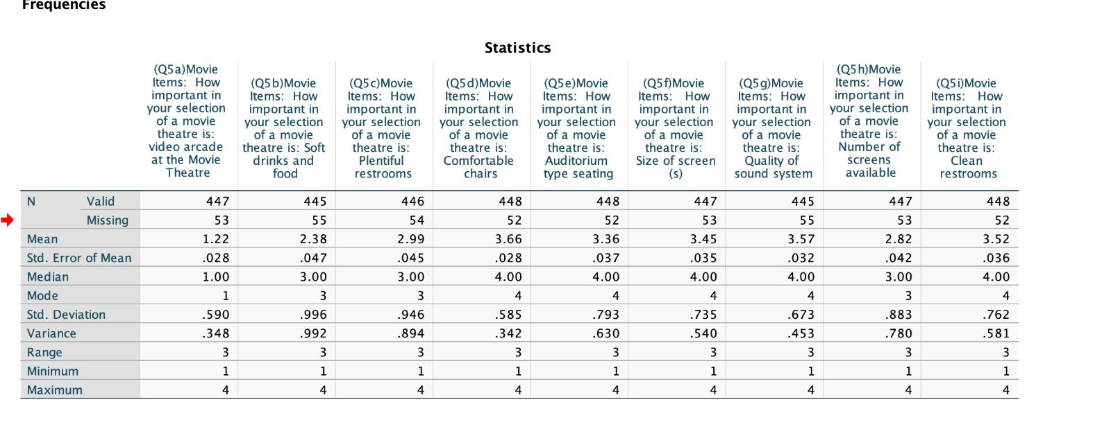

**1. Using only the mean for each of the variables, which of the movie theater items was considered “most important”?**

**Answer:** Comfortable chairs

**2. Using only the standard deviation for each of the variables, for which question was there the greatest amount of agreement? Hint: Least amount of dispersion regarding the response to the movie item.**

**Answer:** Comfortable chairs

**3. Questions 4 and 6 utilize multiple-choice questions that yield nonmetric data but that are ordinal scale. The appropriate measure of central tendency for nonmetric data are the median and the mode.**

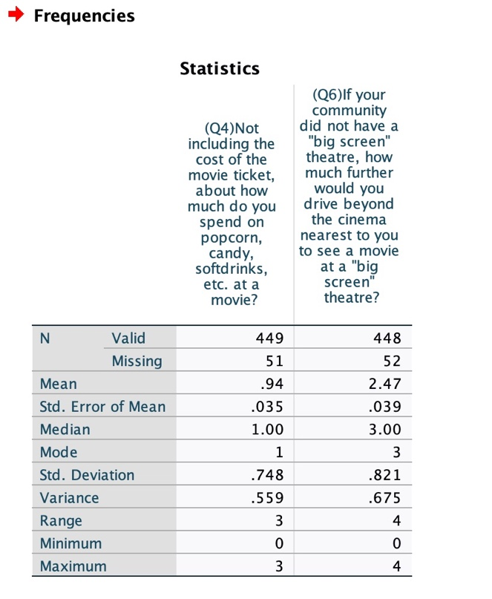

**a. What is the *median* response for question 4, concerning the amount a person spends on food / drink items at a movie?**

**Answer: ``** Median = 1

**b. Concerning question 6, the distance a person would drive to see a movie on a “big screen,” what is the mode of that distribution of responses?**

**Answer:** Mode = 3

**4. In this question, the objective will be to compare the results of median and mean responses for Q3.**

**Answer:**

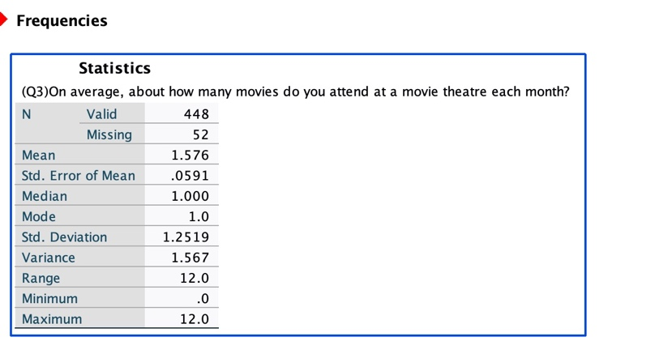

a. Mean response: 1.576

b. Median response: 1.00

c. Standard deviation: 1.2519

d. Minimum response: 0.0

e. Maximum response: 12.0

**5. When the responses to a question contain extreme values, the mean response can lie in the upper or lower quartile of the response distribution. In such a case, the median value would be a better indicator of an average response than the mean value. Given the information you obtained from answering #4 above, is the mean or median a better representative of the “average” response to Q3?**

**Answer:** Median is 1

Chapter 15 SPSS Exercise 4 (20 points)

**EXERCISE 4: Analysis of Demographic Characteristics Using Charts**

If you completed Exercise #1 and/or Exercise #2 you will have the information to complete this exercise. If you did not complete either Exercise #1 or #2, you will need to get a corrected movie attendance database from your professor. After getting the database, use the *analyze/descriptive statistics/frequencies* sequence to obtain frequency distributions for the demographic questions (questions 11–14). Complete the following.

**1. Display the demographic data for each of the four demographic variables in tables.**

**Answer:** copy paste the table from SPSS output below.

**2. For each of the demographic variables, illustrate the table results using some type of graphic representation of the data (pie charts, line charts, or bar charts).**

**Answer:**  SPSS, Excel, Quattro Pro, and some word processing packages can accomplish the task. Copy past the charts below:

**Chapter 16. P.436, SPSS Exercise 3 (30 points).**

**EXERCISE #3: ANOVA Test for Independent Samples**

**Invoke the analyze/compare means/One-Way ANOVA sequence to invoke the ANOVA test to complete this exercise. This exercise compares the responses of freshmen, sophomores, juniors, seniors, and graduate students to test for significant differences in the importance placed on several movie theater items. For the ANOVA test, SPSS calls the variable in which means are being computed the independent variable and the variable in which we are grouping responses the factor variable. Be sure to click the options icon and check descriptive so that the output will produce the mean responses by student classification for the sample data. As with the t test, the ANOVA test produces a table of descriptives based on sample data. If our ANOVA test is significant, the descriptives can be used to determine, for example, which student classification places the most importance on comfortable seats. From our sample data, can we generalize our results to the population by saying that there are significant differences across the classification of students by the importance they place on the following movie theater items?**

**Answer:**

1. Video arcade at the movie theater (Q5a)? No. .548

2. Soft drinks and food items (Q5b)?

3. Plentiful restrooms (Q5c)?

4. Comfortable chairs (Q5d)?

5. Auditorium-type seating (Q5e)?

6. Size of the movie theater screen (Q5f)?

7. Quality of the sound system (Q5g)?

8. Number of screens at the movie theater (Q5h)?

9. Clean restrooms (Q5i)?

**10. Using only descriptive statistics, which classification group (Q13) places the least amount of importance on clean restrooms (Q5i)?**

**Answer:**

**11. Using only the descriptive statistics, which classification group (Q13) places the greatest amount of importance on quality of sound system (Q5g)?**

**Answer:**

**Summarize the results of your ANOVA analysis using a table similar to the one below:**

|  |  |  |  |  |
| --- | --- | --- | --- | --- |
| How important is the following when choosing a movie theatre… | DF | F | Sig | Interpretation |
| a) Video Arcade at the Movie Theatre | 4, 442 | 0.766 | .548 | There are no significant differences between the classifications |
|  |  |  |  |  |
|  |  |  |  |  |
|  |  |  |  |  |
|  |  |  |  |  |
|  |  |  |  |  |
|  |  |  |  |  |
|  |  |  |  |  |
|  |  |  |  |  |

**Group Evaluation Form:**

**For each group project, please fill in the group peer evaluation form under doc sharing. This form enables you to assign individual contribution of each of your group members and express your concerns freely. Please send it with your group together.**

**If there is a unanimous agreement on the misbehavior of an individual member such as failure to accomplish his/her part or lack of cooperation, I will deduct points from this individual student.**

**The peer evaluation form is not mandatory. If you are satisfied with your group members, you don't need to submit it and I will consider that your group members contribute equally.**